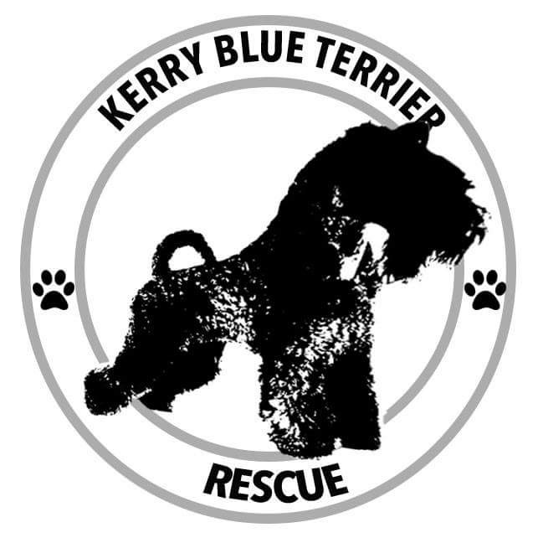
October 2021 Newsletter

To our dear Kerry Blue Terrier friends and family,

We have a very big thank you to you all for your very kind donations, support and offers to help us through a fairly tough time.

The Rescue in General

The Kerry Blue Terrier Rescue is now five years old and we have had a very busy year despite the circumstances and restrictions within which we have had to work. We have continued to work tirelessly to make a difference to the lives of many kerries and their owners. We have also worked hard to inform the greater public about this wonderful breed.

In the year ended 30th September 2021:

- We have had 19 dogs surrendered to us and fully adopted.
- We have helped 6 others rehome their dogs (these others include rescues, kennels and individuals).
- We have given advice and guidance to a further 12 homes, who to date continue to work with their dogs in the knowledge that we will always be there for them, however their adventure unfolds.

Our Team

We have geared up the Rescue for some very busy years ahead and took the decision to create two more posts in order to prepare ourselves. We are delighted to welcome Gemma Ridge to head up our Fundraising team and Peter Bruce to head up our Marketing and Media team. Along with the rest of the team they are both very eager to work tirelessly for the breed and the Rescue, quite often late into the night and throughout the weekends.

We are also very thankful to many other wonderful supporters who really help us out in times of need, even though they are not directly involved with the day-to-day management of the Rescue.

The Future of the Rescue

You may remember that we have always wanted to be formally recognised as a fully-fledged Charity rather than a formally organised Not for Profit entity. Lockdowns and restrictions gave us the time to dedicate to this project. After many months of work by the team and with the support and guidance given by a professional in the Charity sector, (who also has a Kerry) we submitted our paperwork to the Charity Commission. To cut a long story short the Commission felt that our current operation of rehoming, rescue and education did not show enough elements of mental and moral improvement for mankind itself. Whilst it was a great blow to us, and quite a surprising one, we have accepted their decision for now and will not appeal it. That said, we will not leave the idea entirely and will see how our next couple of years unfold and revisit the idea again at a later date.

The Future of the Breed

The Kennel Club currently have the Kerry Blue Terrier categorised as a vulnerable breed. From statistics shown in 2019 we saw a drop of 50% of puppy registrations versus those registered in 2010 (2010 : 212 registered and in 2019 : 109 registered). 2020 saw a great bounce back of registrations and by the end of the year 2020 we saw 161 puppies registered. A further 61 puppies were registered in the first quarter of 2021 and we eagerly await updated results for the following quarters. The price of registered puppies can be a barrier to owning a KC registered pet and we believe that as a result of the increase in demand for dogs in general we saw many non-registered dogs being bred by puppy mills, advertised and sold via social media and online “pet stores” for an inflated price. These purchases unfortunately do not reflect the love and care owners and breeders give in order to nourish their pups and socialise them to the normal trials and tribulations of the wider world. This information coupled with the media information that we all saw during the year of 2020 informing us that many families had opted for a family pet to keep them company and busy made us worry that we would be inundated with these “lockdown dogs” as they are handed to rescues as families and life return to a more recognisable form. Our fear has not yet been realised but we are obviously preparing ourselves for what could be a very busy future.

Our Services, Educational Material & Website

As a result of our application to the Charity Commission and our findings during 2020 we have adapted and grown our services and have also improved on our educational material. As well as redrafting all of our paperwork we have compiled a knowledgeable Breed Advice and Guidance information sheet that will be given to all who are considering a Kerry Blue Terrier, whether they are experienced or not. We feel that it is important to educate the greater public on the character traits of the Kerry Blue Terrier as well as those opening their homes to the typical characters that we see in the rescue. Over the last five years we’ve seen people coming to us requesting a Kerry Blue and quite a few had not researched the breed thoroughly, so our aim has been to find a way in which to connect and educate people with typical traits that we see in the Rescue. Peter has worked tirelessly on educational videos and updating our website, which further enhances our position in the rescue and rehoming world as well as informing our supporters about what we are doing.

We have also expanded our services to provide a help and guidance service to those owners who feel that they are not able to control their dogs’ behaviours. This has a dual purpose. We get to know the dog and the owner and, in some cases, we see that the owners just need that bit of guidance to ensure a stable relationship between them and their dog and ensure that the dog remains at home.

Our Finances for the Year

Income

We continue to rely on 3rd party fundraising events, generous monthly receipts from supporters, one off donations, sales of merchandise and percentages of sales given by businesses. We do not charge people giving up their dogs nor those taking on dogs so our aforementioned income streams are vital to our continued work. Our income flow increased during the year thanks to some amazing people and their fundraising activities.

A special thanks goes to all of the following people:-

  - Stephanie I for handmaking all the lovely Kerry felt ornaments and gifts. Stephanie has also been taking her Kerry, Magnus, to do talks on the breed and demonstrations on how to train and has given all donation received at those talks to the Rescue.

  - Judith B for donating some wonderful gifts for our auctions and her immense help to the team on a regular basis.

  - Maria I for handmaking some wonderful dog themed masks. These masks are still being purchased for grooming, especially useful when filing nails down or combing through very dusty dogs and can be found in our online store. https://www.kerrybluerescue.co.uk/kerry-blue-store.html

  - Becki E for giving us the right to auction off some of her lovely 2020 Christmas Kerry photographic montages.

  - Aileen T of K9 Clean Coats for donating a large portion of her sales income received for any coats made for a Kerry. www.k9cleancoats.co.uk

  - Our very own Gemma R for her incredible skydive. Gemma has been terrified of heights all her life and decided to confront that fear in aid of our Rescue. Gemma raised an eye watering total for the Rescue of £ 1,350.00.

  - Shona M who along with her Kerry, Betty, has now tackled way over 100 Munros. In April 2021 Shona announced that she and Betty would be tackling the Inaccessible Pinnacle, the most challenging peak in the Skye Cuillin ridge along with other 10 Munroe peaks of the Cuillin ridge. This involved some serious weather challenges, coupled with climbing and abseiling off the top. Many of you will remember the wonderful photos of Betty strapped into the guides backpack to keep her safe as Shona, Betty and the guide made their way up and abseiled down. In total there are 282 Munros and I have a feeling that Shona and Betty have a plan to bag the lot as we still see them via Facebook braving the elements (and they can be very harsh) out there on the Skye Munros. Shona and Betty raised £1,380.00 for the Rescue.

  - Cara S has also continued to send a percentage of her Kerry related sales too, so if you’re thinking of doing some early Christmas shopping, please head to her online shop at www.maisieandmurphy.co.uk/

We are not able to leave the thanks there. We also wish to thank:-

  - Paul for his wonderful handmade leads and collars, which are still for sale in our online shop.
  - Alison from Hounds in Pounds for her generous donations made from auctions and sales.
  - Irene W for her wonderful Kerry gifts and memorabilia. More information on this will be available in Spring 2022.
  - Our own team member Peter for his percentage of sales on his wonderful Kerry drawings www.peterbruce.co.uk. Please visit his website if you’re looking for a special Christmas present, you won’t be disappointed.

A very heartfelt mention also goes to a dear family who set up a Memory Giving donation page so that funds could be sent to us in the memory of a loved one who had passed away. All of their family have adored Kerry Blues all their lives and this was such a lovely tribute.

Lastly but certainly not least we’d like to say how appreciative we are to all those people who send in monthly donations to the Rescue. It is very comforting to know that because of these funds and your generosity we never have to turn a dog away because we are unable to meet our possible financial obligations. As I’ve said before we absolutely couldn’t do what we do without you all.

Expenditure

Our expenditure has been much lower throughout the year than in previous years and this is largely due to the lack of medical attention needed by dogs who were surrendered to us. Last year we spent a total of £10,745 whereas this year vets’ fees spent have only totalled £ 2,800. Only eight of the foster dogs have needed medical attention, there have been two dogs who needed kennelling, training and grooming and all of our foster parents have kindly purchased everything that the dog under their care needs.

We have taken the opportunity to buy another couple of years supply of degradable poop bags and the Calendars for 2022 so in total we have spent £2,108 during the year. This was represented by the 2021 and 2022 calendars and the poop bags.

The Future

As with many rescues we expect to be very busy over the next few years so it is paramount for us to start planning now. Our belief is that whilst the Rescue is here, potential owners and current owners of Kerries will always have a place to come to for advice or help in the rehoming process.

Our 2022 Christmas Shopping Experience

Our 2022 calendars, poop bags and Kerry Christmas decorations, are now officially on sale. So please head to https://www.kerrybluerescue.co.uk/kerry-blue-christmas-store.html and have a look and make your order. Please send your order along with your postal address in an email remembering to add your choice of ornament (eg angel, cracker etc) to me, Emma at kbtr.sales@gmail.com and I will send you the payment details and an unique reference number to quote when making your payment. As soon as I see your payment, I will send you a confirmation of safe receipt of funds and confirmation that your order is being packed and will be on its way within the following few days.

On behalf of all the dogs who pass through us we want to say thank you to each and every person who has supported the Rescue and enabled us to help all of the dogs. You’re all amazing.

Please stay safe, keep calm and kerry on!
With love from the whole team of the Kerry Blue Terrier Rescue

Emma Bendel
Treasurer

